Adjustable Spine & Hinge Creaser
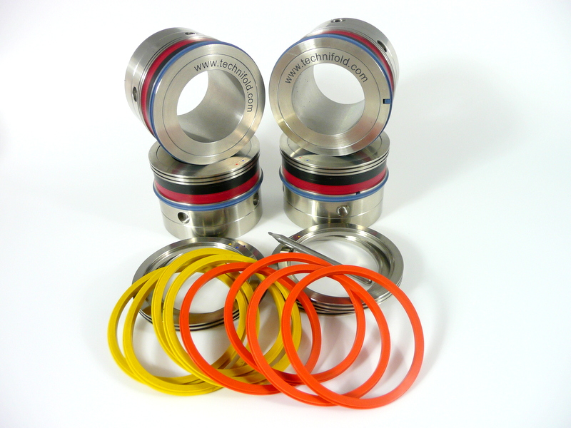
using Easy Fit crease Ribs

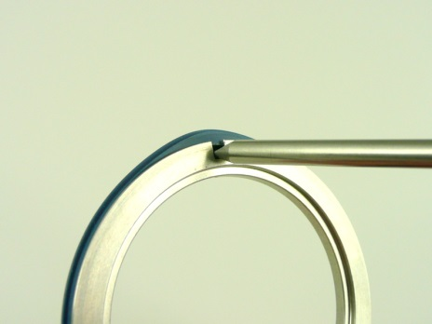
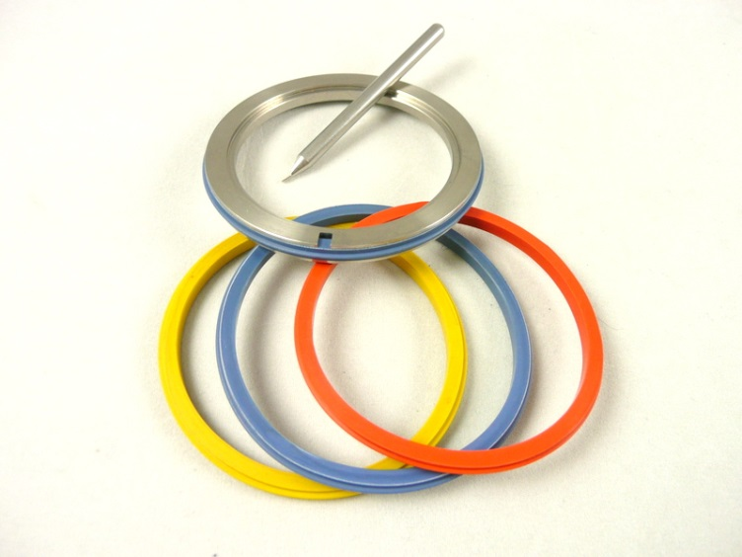
Setting procedure

4x Orange Gripper Crease 100-200gsm
4x Blue Gripper Crease 200-270gsm
4x Yellow Gripper Crease 250-350gsm

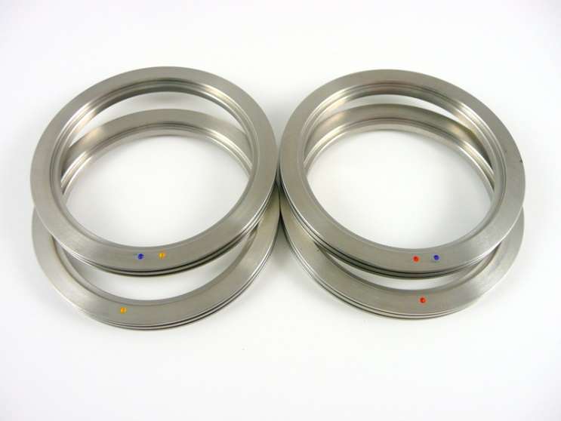

Orange 100-170gsm
Orange & Blue 150-200 gsm
Blue & Yellow 200-275gsm
Yellow 250-350gsm
Select the male creasing rib colour and insert onto the holder

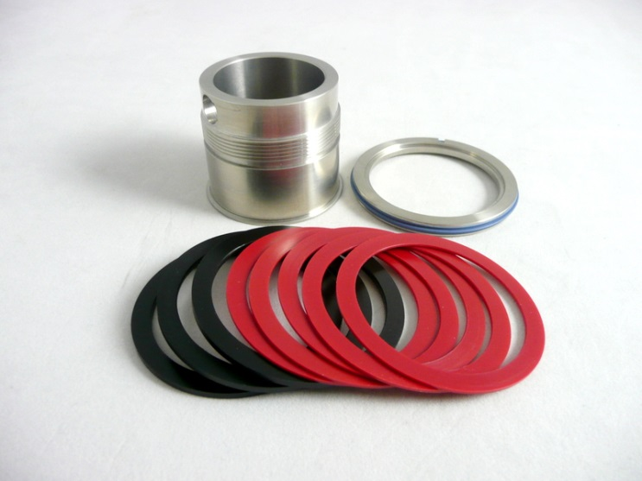

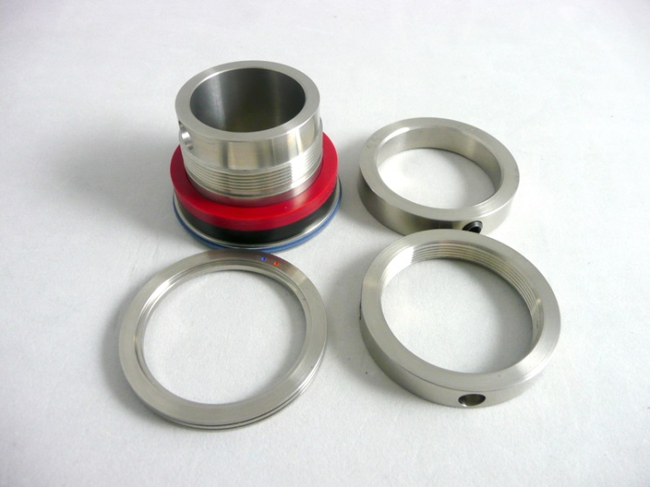

Select the correct colour coded female for the paper being creased and using the colour red and black spacers obtain the correct hinge distance.

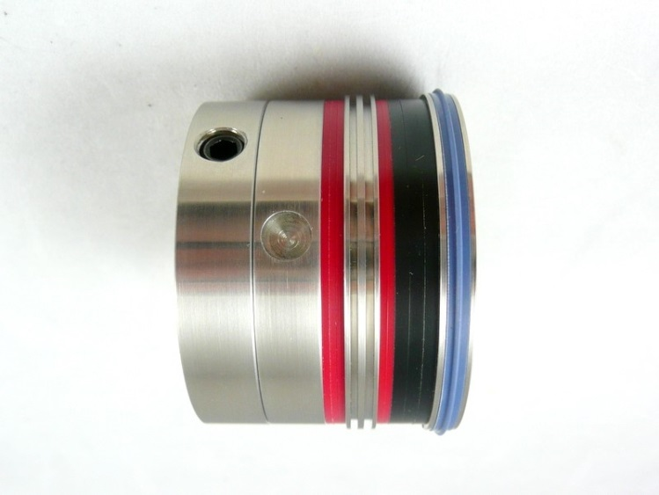

The minimum creasing distance between each individual unit is 4mm the maximum is 17mm

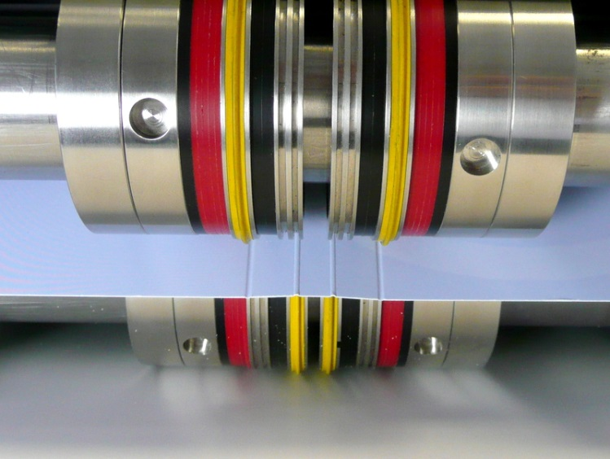

Use the same colour coded crease ribs and females. The top and bottom units should aligned together

Position the bottom shaft crease units into the desired position and tighten the fixing screws to the shaft.

As the top shaft is being lowered, slide the male rib protrusions into the corresponding female channels. DO NOT TIGHTEN THE SHAFT FIXING SCREWS

Slowly run a sheet of cover stock between the top and bottom crease units. As the cover stock rotates through the crease units the loose top crease units automatically move into the optimum crease position. When the shaft fixing screws come into view and with the paper is still gripped in between the crease units, tighten the top fixing screws to the shaft.
The Spine & Hinge units are now ready to try

